**FORTITUDE REINSURANCE COMPANY LTD.**

**BUSINESS PLAN**

**(REVISED APRIL 2020)**

**Executive Summary**

Fortitude Reinsurance Company Ltd. (the “Company” or “Fortitude Re”) was incorporated as an exempted company in Bermuda on January 1, 2017 as SAM Reinsurance Company Ltd. The Company changed its name to DSA Reinsurance Company Ltd and subsequently to Fortitude Reinsurance Company Ltd. Fortitude Re was registered as a Class 4 and Class E composite reinsurance company for the initial purpose of serving as a reinsurer of the legacy insurance portfolio of American International Group, Inc. (AIG). The portfolio is comprised of two main legacy business segments: Life & Annuities and Property & Casualty business (collectively, the “Legacy Business”).

**Formation; Ownership**

AIG publicly announced the strategic establishment of a new Legacy operating segment in January, 2016. The Legacy segment represents Legacy Investments and Legacy Insurance Run-Off books. Through the formation of the Company, AIG intended to achieve operating and capital efficiencies by consolidating its legacy insurance books of business, while defeasing policyholder/insured obligations of the AIG reinsured companies. AIG and the Company seek to manage, control and resolve AIG’s legacy insurance liabilities while honoring all policy obligations and respecting the primary insurer’s client relationships and policyholder service expectations.

In November 2018, AIG completed the sale of a 19.9% ownership interest in Fortitude Group Holdings (Fortitude Holdings), LLC to TC Group Cayman Investment Holdings, L.P. (TCG), an affiliate of The Carlyle Group L.P. Fortitude Holdings was formed to act as a holding company for Fortitude Re. Fortitude Holdings holds 100% of the outstanding units of Fortitude Re; AIG has an 80.1% ownership interest in Fortitude Holdings and TCG has a 19.9% ownership interest. An organization chart showing current ownership and legal entity structure of the Company is provided in Appendix A1.

On November 25, 2019, AIG, TCG and T&D Holdings, Inc. (T&D) announced that a newly created Carlyle-managed fund and T&D had partnered to acquire from AIG a 76.6% ownership interest in Fortitude Holdings for approximately $1.8 billion. After closing, ownership interests in Fortitude Re will include Carlyle and its fund investors at 71.5% (including the 19.9% stake previously acquired by Carlyle in November 2018), T&D at 25% and AIG at 3.5%. Under the parties’ agreements, AIG will receive a $500 million non-pro-rata distribution, which if not paid by dividend from Fortitude Holdings will result in an additional payment from the Carlyle-managed fund and T&D based on their Fortitude Re ownership interests. We currently anticipate the transaction to close in mid-2020 (“Closing”), subject to required regulatory approvals and other customary closing conditions. An organization chart showing future ownership and legal entity structure after the Closing is provided in Appendix A2.

**Capital Position of the Company**

Since the Company was established with Total Statutory Economic Capital and Surplus of approximately US$3.9 billion as of February 2018[1], its Total Statutory Economic Capital and Surplus has increased to US$4.3 billion as of 12/31/2019, resulting in a strong capital position with an ECR ratio of 233%, significantly greater than the Company’s target ECR ratio of 150% (“Baseline Target Capitalization Level”). During the financial year 2019, the Company retained all economic earnings and distributed no capital to parent. Absent new transactions, and subject to BMA approval, we will consider paying dividends when capital is in excess of 175 ECR%. The deployment of capital into new business opportunities will be considered opportunistically, also subject to applicable BMA approvals.

AIG provides the Company with an unconditional Capital Maintenance Agreement (CMA). Under the CMA, AIG will replenish capital levels each quarter should the projected capitalization level of either or both the Long Term Business Fund or General Business Account (each a “Fund”) fall below the Stress Threshold level of 125% of the Enhanced Capital Requirement (ECR) for Fortitude Re as apportioned by the Company between each Fund. Per the CMA, the Company is required to suspend dividends from the applicable Fund should the ECR ratio in respect of such Fund be below 150% of the ECR. The CMA also permits replenishment of capital by AIG of either Fund at any time to restore capitalization to the Baseline Target Capitalization Level for such Fund. AIG also agrees not to terminate the CMA unless it sells more than 50% of the voting securities of Fortitude Re. Accordingly, it is anticipated that the CMA will be terminated at Closing.

[insert high level details of term loan and revolver]

**The Reinsured Liabilities**

The Company’s current reinsured portfolio consists of legacy portfolios ceded or novated by a number of AIG companies, including American General Life Insurance Company and other AIG life and annuity companies (collectively, the “Life Cedants”) and certain blocks of P&C business issued by National Union Fire Insurance Company of Pittsburgh, Pa. and other AIG property and casualty companies (collectively, “P&C Cedants”) as identified in Appendix B (the Life Cedants and P&C Cedants are collectively referred to as the “Cedants”) with such portfolios subject to revision as business conditions warrant.

The Life Cedants have ceded the life and annuity blocks of the Legacy Business to the Company on a modified coinsurance basis. The P&C Cedants have ceded the property and casualty blocks of the Legacy Business to the Company through loss portfolio transfer reinsurance agreements, each of which includes its own reinsurance limit. The obligations of the Company under the loss portfolio transfer agreements are collateralized using a funds withheld structure.

The Legacy Business ceded to the Company by its Cedants comprises 14 lines of business across the two main business segments as shown in Appendix C.

American International Reinsurance Company, Ltd. (“AIRCO”) assumed a closed block of pension annuities through a reinsurance agreement from Phoenix Life Ltd. (the “Alba Business”). Via a novation agreement among AIRCO, AIG Life of Bermuda, Ltd. (“AIGB”) and Fortitude Re, AIRCO retrocedes to Fortitude Re on a funds withheld basis 100% of the obligations associated with the Alba Business that was formerly retroceded to AIGB.

The Company made an election to be treated as a US corporation under section 953(d) of the Internal Revenue Code of 1986 (a “Section 953(d) election”), with an effective date of 1 January 2018.

**Financial Projections**

An overview of the Company’s Bermuda Solvency Capital Requirement (BSCR) is provided in Appendix D1 and pro-forma financial statements for calendar years 2020-2024 including a draft statutory balance sheet, statutory income statement, statutory capital and surplus statement, economic balance sheet and capital requirements. A summary of key assumptions is also included.

Risk retention by class

* Long Term business

The Company assumes 100% of the Life Cedants’ net (after other reinsurance) exposure on the Life and Annuity books of business it reinsures and the Company does not currently purchase any ceded reinsurance on this business. None of the subject annuity business is currently reinsured internally or externally.

* Property and Casualty

The Company assumes 100% of its Cedants’ net exposure on the P&C books of business it reinsures and the Company does not currently purchase any ceded reinsurance protection on this business.

Only net (after other reinsurance) liabilities are subject to the Loss Portfolio Transfers. For the cessions of workers’ compensation and certain environmental business, net liabilities (a) include recoverables otherwise due under external reinsurance agreements commuted or written off prior to January 1, 2017 but (b) deems as collectible all other recoverables due under external reinsurance agreements, as in effect at January 1, 2017.

Future business

The Company intends to actively underwrite run-off and other retroactive and “back book” reinsurance (e.g., loss portfolio transfers, adverse development covers) on a global basis. The Company will also thoughtfully consider opportunities to reinsure portions of its portfolio.

The Company has progressed its development of an acquisition platform consisting of actuarial, underwriting, claims, IT, and human resources solutions. The actuarial underwriting team will incorporate structural-driver based considerations in the valuation of liabilities, both on the P&C and the life side. In establishing its pricing structures, the Company draws on extensive research performed on economic and societal influences on the development of insurance liabilities, including mortality, inflation, and the tort environment. The Company will also seek to provide claims solutions for clients that seek to transfer long-tail P&C portfolios, including the intake of experienced claims staff.

The Company will seek to use acquisitions to further balance longevity and mortality risk, both within its life portfolio and across P&C (e.g., workers’ compensation, which embodies longevity risk). We expect the European market to continue to generate mortality and longevity blocks, as insurers continue to adjust to Solvency II requirements. All acquisitions are to be evaluated under a consistent disciplined pricing framework, to ensure profitability standards are achieved, and within the Company’s risk appetite. The Company will maintain an open dialogue with the Authority regarding any acquisition opportunities the Company intends to pursue.

The size of the Company’s portfolio and the strength of its balance sheet puts the Company in the top tier of run-off reinsurers by potential transaction size, both for P&C and life risks. The Company therefore expects to deliver a competitive advantage in the marketplace as a source for potential transactions.

**P&C Claims and Loss History**

* Loss Assumptions

The P&C portfolio is long-tailed, with an average weighted lifetime of approximately 11 years. The longest-tail book is excess workers’ compensation for accident years 2011 and prior, which is mature, yet has a remaining average weighted lifetime of approximately 18 years, and a PVBE (present value best estimate) of approximately US$1.27 billion. The largest P&C book consists of Pollution Liability Products, with a PVBE of loss and loss adjustment reserves of US$1.34 billion and an average weighted lifetime of approximately 5 years. Taken together, these two books account for just over 69% of the reinsured open P&C claims as of 12/31/19.

**Risk Management Framework and Operational Model**

The Company continues to enhance its risk management framework to ensure successful business operations and sustainable, long-term profitability. The Company’s strong risk management culture is articulated by its senior leadership and embodied by management at all levels through the governance structure and risk management processes. The Company is subject to risks that are addressed in the Company’s risk management framework, including the adoption of risk policies in compliance with the Authority’s Insurance Code of Conduct: underwriting; investment, liquidity and concentration; market; credit; systems and operational; group; strategic; reputational; and legal/litigation.

The framework, which is currently comprised of applicable AIG group and local policies, will be replaced at Closing by Fortitude Re-specific policies defining risk management processes and controls adopted across our businesses and underpinned by risk management information, including the results of stress testing and scenario forecasting programs; specifically the enterprise-wide capital and liquidity stress testing framework (known as enterprise-wide stress testing) that assesses the impact to capital and parent-company liquidity under a range of scenarios, the BMA prescribed stress tests as defined in the Bermuda Solvency Capital Requirement template, and our internally determined Commercial Insurers Solvency Self-Assessment (“CISSA”).

The Company has established a ‘Statement of Risk Appetite’ to align strategic business goals against the risks and volatility faced in executing plans, ensuring risks are maintained at levels consistent with the Company’s financial resources. This ensures a business environment that supports controlled risk-taking to generate sustainable earnings and delivery of long-term value for the Company.

The Board is responsible for providing suitable prudential oversight of the Company’s risk management and internal controls framework, including any activities and functions that are delegated or outsourced. An independent, fit-for-purpose risk management organization will be closely aligned with and will actively support business management teams throughout the business life cycle, engaging early and often and driving risk assessment through the utilization of controls and metrics. To achieve this, the Company’s Chief Risk Officer is responsible for the risk management framework at the company utilizing a “Three Lines of Defense” model.

See Appendix E for a summary of the risk management framework and description of the “Three Lines of Defense” model as well as a summary of the stress testing results.

**Claims Handling**

* **Long-Term business**

The majority of the Company’s life and annuity liabilities are currently managed by a dedicated staff of experienced AIG claim professionals, based primarily in the United States, and third-party service providers. Servicing of certain sub-portfolios (including but not limited to Long Term Care, Group Cancer, and a portion of the life business) is currently outsourced by AIG to independent third-party administrators.

It is anticipated that, following Closing and upon approval by the Life Cedants’ regulators, Fortitude Life & Annuity Solutions, Inc. (FLAS), a licensed life & annuity third-party administrator that was established as an affiliate of the Company, will assume from the Life Cedants responsibility for administration of portions of the long term business ceded to the Company. Until such time, it is anticipated that FLAS will be transferred back to AIG and the Life Cedants will retain responsibility for the administration of the life & annuity business ceded to the Company.

* **Property and Casualty**

The Company’s P&C claim liabilities are currently managed by a dedicated staff of AIG experienced claim professionals, based in the United States, as well as third-party administrators. It is anticipated that, following Closing and upon approval by the P&C Cedants’ regulators, DSA P&C Solutions, Inc. (DSA), a licensed property & casualty claims adjuster that was established as an affiliate of the Company, will assume from the P&C Cedants responsibility for most of the claims handling responsibilities with respect to the ceded P&C portfolios. Until such time, it is anticipated that DSA will be transferred back to AIG and the P&C Cedants’ affiliate, AIG Claims, Inc., will retain responsibility for the handling of the P&C business ceded to the Company.

**ALM Investment Strategy**

Fortitude Re has developed an asset and liability management strategy that incorporates the Company’s risk appetite and the BMA’s investment limits, including detailed BMA guidance regarding allowable asset classes to match the long-term liability cash flow obligations. Fortitude Re plans to use primarily investment grade fixed income to cash-flow match liability cash flows within the first 30 years. For liability cash flows beyond 30 years, Fortitude Re will invest in the limited supply of fixed income maturing beyond 30 years and use alternative assets to seek to generate excess cash flows that can be reinvested into traditional fixed income as the liabilities roll-down into the more investable range (i.e., less than 30 years). Fortitude Re’s surplus, as well as the ModCo and LPT asset portfolios are currently managed by AIG Asset Management and Carlyle. The ModCo and LPT reinsurance and asset management agreements, which include the investment guidelines for the ModCo and LPT funds withheld, are each subject to applicable US regulatory requirements.

Please refer to the Company’s application titled “Approval of Investment Strategy and Asset Classes for Long Tailed Liabilities” dated as of April 3, 2019 for more detailed information on investment strategy.

**Corporate Governance**

* Organizational Structure

The Company is organized into various operating units reporting into the Company’s Chief Executive Officer as illustrated in Appendix D3.

* Board of Directors

As of April 2020, the Company’s Board of Directors is as follows:

Geoffrey Cornell

Douglas Dachille

Thomas Diemer

Spencer Gluck

Kevin Hogan

Brian O’Hara (independent director)

Richard Patching (independent director)

Sabyasachi Ray

Brian Schreiber

Anthony Vidovich

Samuel Weinhoff

Completed Director Personal Declaration forms for all Directors have previously been submitted to the Authority.

* Board Committees

As of April 2020, Company’s Directors have the following committees:

* Audit
* Risk and Capital (including Investments)
* Life & Annuity Reinsurance & Claims
* Property & Casualty Reinsurance & Claims
* Compliance

Please see Appendix G for a summary of committee membership. The Directors have adopted charters for each of its appointed committees, copies of which have been previously provided to the Authority.

* Secretary

Jeannine Menzies is currently the Company Secretary and Gary Harris is the Company’s Assistant Secretary.

* Senior Management Team

As of April 2020, the Company’s senior executives include:

James Bracken, Chief Executive Officer

Jeffrey Burman, General Counsel

Sean Coyle, Chief Operations Officer & Interim Head of Human Resources

Jinney Kim, Head of Strategy and Special Projects

Jeffrey Mauro, Chief Investment Officer

Jack McGregor, Head of Inforce Management, Property & Casualty

Seong-Weon Park, Head of Forecasting & Capital

Andrew Sooboodoo, Chief Risk Officer

Kai Talarek, Chief Financial Officer

James West, Interim Head of Inforce Management, Life & Annuity

* Company Contact persons for the Authority

Gary Harris and Andrew Sooboodoo are the day- to-day contact persons for the Authority. Their contact details are as follows:

* [gary.harris@fortitude-re.com](mailto:gary.harris@fortitude-re.com) or +1 441 599 9987; or
* [andrew.sooboodoo@fortitude-re.com](mailto:andrew.sooboodoo@fortitude-re.com) or +1 615 457 8291.

**Compliance with Head Office Requirements**

It is intended for all regularly scheduled Company Board of Directors and Committee meetings to be held in Bermuda on a quarterly basis. In addition, it is the Company’s practice to hold management meetings in Bermuda. Through these meetings, risk management and operational decision making occur in Bermuda.

Directors who reside in Bermuda include Richard Patching and Brian O’Hara. Current senior officers resident in Bermuda include Andrew Sooboodoo (Chief Risk Officer and Principal Representative) and Gary Harris (General Counsel, Compliance Officer, Money Laundering Reporting Officer, Privacy Officer and Assistant Secretary for Fortitude Re Bermuda).).

The Company’s principal office and registered address is in Bermuda. The Principal Representative and the Company’s auditor are based in Bermuda. Books and records of the Company are held at the Company’s Principal Office.

**Principal Office and Registered Office**

The Company’s principal and registered office is located at Chesney House, 3rd Floor, 96 Pitts Bay Road, Pembroke HM08, Bermuda.

**Principal Representative**

Andrew Sooboodoo is the Company’s principal representative.

**Loss Reserve Specialist**

Chris Nelson is the Company’s Loss Reserve Specialist.

**Actuary**

James West is the Company’s Actuary.

**Auditors**

The Company’s Board of Directors has appointed PricewaterhouseCoopers, Bermuda (“PWC”) as its approved independent auditor.

**Outsourcing**

It is expected that post-Closing, the Company may on a limited basis require certain services from, and anticipates entering into transition services agreements with, one or more AIG affiliates. These services may include, but may not be limited to, treasury and investment management services, claim and actuarial data support, policyholder billing and collection services, and corporate functional support. The Company also receives functional support services (e.g., FP&A; actuarial; legal) from its affiliate Fortitude Group Services, Inc.

The Company intends to comply with the outsourcing provisions provided in the Authority’s Insurance Code of Conduct.

Please refer to Appendix I for a current list of unaffiliated TPAs relevant to the Company’s blocks of business.

**Maintenance of Records**

The Company maintains all of its books and records of account and related records in its principal office in Bermuda.

**U.S. Regulators**

AIG’s U.S.-based regulatory contacts are provided in Appendix H.

APPENDIX A1

Legal Entity Organizational Chart

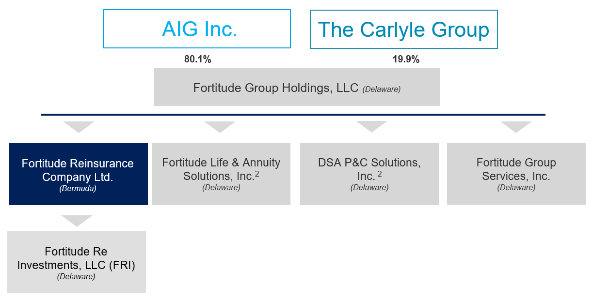

APPENDIX A2

Legal Entity Organizational Chart Post-Closing of Sale Transaction

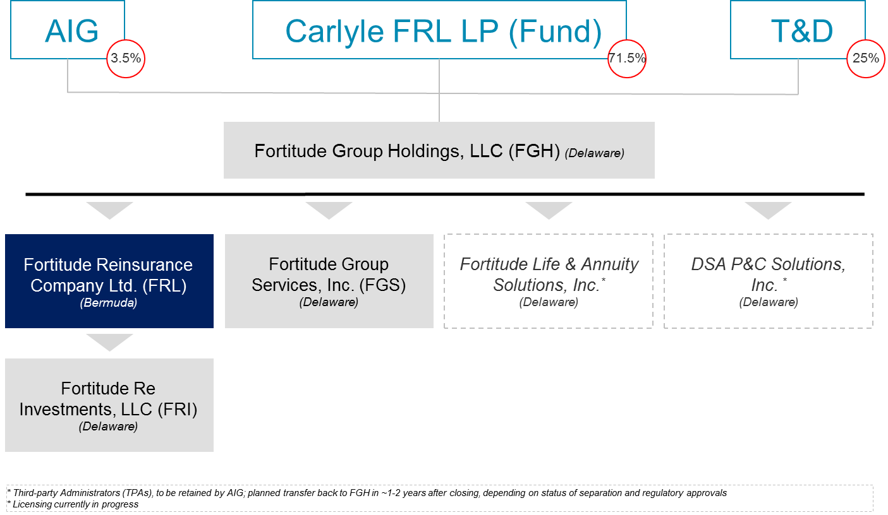

APPENDIX B

Fortitude Re’s AIG Cedant/novation counterparties

|  |  |  |  |
| --- | --- | --- | --- |
| **Group** | | **Legal Entity (abbreviation)** | **State** |
| **1** | **AIG US Life Insurers** | American General Life Insurance Company (AGL) | TX |
| The Variable Annuity Life Insurance Company (VALIC) | TX |
| United States Life Insurance Company in the City of New York (USL) | NY |
| **2** | **AIG Bermuda Insurers** | AIG Life of Bermuda (AIGB) | Bermuda |
| American International Reinsurance Company (AIRCO) | Bermuda |
| **3** | **AIG US P&C Insurers** | AIG Property Casualty Company | PA |
| National Union Fire Insurance Company of Pittsburgh, Pa.(NUFIC) | PA |
| The Insurance Company of the State of Pennsylvania | PA |
| AIG Assurance Company | PA |
| AIG Specialty Insurance Company | IL |
| Granite State Insurance Company | IL |
| Illinois National Insurance Co | IL |
| New Hampshire Insurance Company | IL |
| AIU Insurance Company | NY |
| American Home Assurance Company | NY |
| Commerce and Industry Insurance Company | NY |
| Lexington Insurance Company (Lexington) | DE |

APPENDIX C

Lines of Business ceded to the Company

|  |  |  |  |
| --- | --- | --- | --- |
| Line of Business | | Cedants[2] | Comments |
| **Life** | |  |  |
| **ROP Term** | AGL  USL | * Insurance Risk: Mortality, lower lapses * Reinvestment risk to due to endowment feature |
| **Whole Life**  (Par & Non-Par) | AGL  USL | * Insurance risks: mortality, surrenders and loan utilization * Includes legacy policies from Franklin Life Insurance Co. (acquired by AIG in 2001) and other miscellaneous lines primarily in Industrial Whole Life |
| **Universal Life**  (Closed Portfolio)[3] | AGL  USL | * Insurance risks: mortality, surrenders and loan utilization * Express Issue Whole Life, Inheritance Life, Single Premium Life, and SunAmerica Life[4] |
| **Accident & Health** | AGL  USL  NUFIC | * Insurance risk: morbidity * Various legacy medical, hospital and disability mini-portfolios |
| **Long-Term Care** | AGL  USL | * Insurance risks: morbidity, regulatory risk in applying for rate increases * Exposed to inflation risk * Significant prior loss recognition due to difficulties in the LTC |
| **Payout Annuities** |  |  |
| **Structured Settlements** | AGL  USL  VALIC | * Insurance risk: longevity |
| **Single Premium Immediate Annuities** | AIGB | * Insurance risk: longevity |
| **Terminal Funding Annuities[5]** | AGL  USL  AIGB | * Insurance risk: longevity * In addition to the US Life & Retirement Portfolios, TFAs include a TFA on Scottish lives currently reinsured to AIRCO and retroceded to Fortitude Re. |
| **Property & Casualty** |  |  |
| **Excess Workers Compensation** | U.S. Pool | * Insurance risks: longevity, regulatory risk, changes in medical practices; medical inflation; and technology * Exposed to medical inflation and cost of living adjustments * Workers comp written above a self-insured retention; excludes WTC 9/11 claims |
| **Pollution Liability Products** | U.S. Pool | * Insurance risks: cleanup standards * Includes: Environmental Corporate Pollution, Environmental Corporate Casualty, and Environmental Protection Program |
| **Legacy Environmental (Incidental Liability)** | U.S. Pool | * Insurance risks: unintentional coverage * Environmental losses from incidental liability (1987 and prior) * Comes from: General Liability, Products Liability, or Commercial Multi-Peril coverages |
| **Healthcare (misc. exited coverage)** | U.S. Pool | * Insurance risks: judicial climate * Includes Physicians & Surgeons PL, Pharmaceutical, Equipment, Product Recall, and other healthcare coverages * Includes primary, excess, and assumed reinsurance coverage. Includes both occurrence, and claims made coverages. Excludes specific “Special Accounts” |
| **Commercial Auto (Buffer Trucking)** | U.S. Pool | * Insurance risks: judicial climate * From Lexington Buffer Trucking Facility * Commercial Auto Liability for short and long haul trucks since 1986. Primarily covers buffer layer from $2.0M - $8.0M in liability |
| **Other Casualty** | U.S. Pool | * Insurance risks: miscellaneous * Contains: Occupational Accident, Public Entity Excess Liability, Major Accounts, National Accounts, Specialty Programs, China America, and smaller casualty programs |

APPENDIX D1

2019 BSCR

|  |  |  |  |
| --- | --- | --- | --- |
| BSCR Capital Requirement ($MM) | Current Regime  (80%) | New Regime  (20%) | Weighted |
| Fixed Income Investment Risk | 848 | 848 |  |
| Equity Investment Risk | 764 | 764 |  |
| Interest Rate / Liquidity Risk | 399 | 22 |  |
| Currency Risk | 27 | 27 |  |
| Concentration Risk | 79 | 153 |  |
| PC Reserve Risk | 1,168 | 1,183 |  |
| Mortality | 71 | 71 |  |
| Morbidity & Disability | 21 | 21 |  |
| Longevity | 511 | 511 |  |
| Other Insurance Risk | 292 | 292 |  |
| BSCR (After Correlation Adjustment) | 1,779 | 2,111 |  |
| Operational risk capital charge | 89 | 106 |  |
| BSCR Before Tax Adjustment | 1,868 | 2,217 |  |
| Tax Credit (Loss Absorbing Capital ) | 0 | 443 |  |
| BSCR After Tax Adjustment | 1,868 | 1,774 | 1,849 |

APPENDIX D2

Pro-forma financial statements

**Five-year Statutory Balance Sheet**

|  |  |  |  |  |  |
| --- | --- | --- | --- | --- | --- |
| **Statutory Balance sheet ($ M)** | **2020** | **2021** | **2022** | **2023** | **2024** |
| Fixed Investments | 38,584 | 43,283 | 49,294 | 52,564 | 53,612 |
| Alternative investments | 2,739 | 2,996 | 3,370 | 3,339 | 3,201 |
| Hedges | 211 | 191 | 178 | 166 | 147 |
| Letters of credit/Term Loan/Debt Proceeds | 550 | 550 | 550 | 550 | 550 |
| DTA / (DTL) | (475) | (404) | (320) | (269) | (232) |
| Total assets | 41,609 | 46,616 | 53,072 | 56,350 | 57,277 |
|  |  |  |  |  |  |
| GI Reserves (Inforce as of 2019) | 3,638 | 3,270 | 2,959 | 2,631 | 2,391 |
| GI Reserves (New Business) | 0 | 795 | 1,715 | 2,297 | 2,610 |
| LT Reserves (Inforce as of 2019) | 29,866 | 29,171 | 28,470 | 27,732 | 26,977 |
| LT Reserves (New Business) | 0 | 5,255 | 11,639 | 15,448 | 17,200 |
| Total reserves | 33,505 | 38,491 | 44,784 | 48,107 | 49,178 |
| Deferred gain on reinsurance | 2,304 | 2,169 | 2,046 | 1,933 | 1,828 |
| Capital and surplus | 5,799 | 5,956 | 6,242 | 6,309 | 6,271 |
| Total liabilities and capital & surplus | 41,609 | 46,616 | 53,072 | 56,350 | 57,277 |

**Five-year Statutory Income Statement**

|  |  |  |  |  |  |
| --- | --- | --- | --- | --- | --- |
| **Statutory Income Statement ($ M)** | **2020** | **2021** | **2022** | **2023** | **2024** |
| **Inforce as of 2019** |  |  |  |  |  |
| Net premiums written | 294 | 280 | 266 | 253 | 239 |
| Decrease in unearned premium (PC only) | 21 | 24 | 20 | 46 | 20 |
| Total income | 315 | 303 | 287 | 300 | 259 |
|  |  |  |  |  |  |
| Net loss and net loss expenses incurred (PC only) | (496) | (412) | (352) | (375) | (279) |
| Death claims (LR only) | (304) | (299) | (295) | (290) | (284) |
| Surrenders (LR only) | (186) | (177) | (174) | (189) | (216) |
| Maturities (LR only) | (27) | (27) | (24) | (27) | (24) |
| Annuities (LR only) | (1,671) | (1,644) | (1,603) | (1,573) | (1,521) |
| A&H benefits (LR only) | (96) | (99) | (101) | (101) | (101) |
| Cash dividends (LR only) | (1) | (1) | (1) | (1) | (1) |
| Commissions and Premium Tax (LR Only) | (9) | (9) | (9) | (9) | (9) |
| Change in reserves and reinsurance recoverables | 1,106 | 1,040 | 992 | 1,020 | 975 |
| Total disbursements | (1,685) | (1,629) | (1,567) | (1,545) | (1,461) |
|  |  |  |  |  |  |
| Maintenance expenses | (49) | (47) | (45) | (44) | (42) |
| General overhead expenses | (57) | (54) | (51) | (48) | (45) |
| Operating expenses | (106) | (100) | (96) | (92) | (88) |
|  |  |  |  |  |  |
| Net investment income | 1,673 | 1,753 | 1,651 | 1,559 | 1,491 |
| Amortization of deferred gains | 153 | 136 | 123 | 113 | 105 |
| Realized capital gains (losses) on embedded derivative | (349) | (363) | (357) | (296) | (287) |
| Cost of LOC/Term Loan/Debt | (17) | (19) | (19) | (19) | (19) |
|  |  |  |  |  |  |
| Income before taxes | (17) | 81 | 22 | 19 | (0) |
| Income tax provisions | 4 | (17) | (5) | (4) | 0 |
|  |  |  |  |  |  |
| **New Business** |  |  |  |  |  |
| Return from New Business | 0 | 0 | 65 | 133 | 180 |
| Net Income | (13) | 64 | 82 | 148 | 180 |

**Five-year Statutory Capital and Surplus Statement**

|  |  |  |  |  |  |
| --- | --- | --- | --- | --- | --- |
| **BERMUDA STATUTORY CAPITAL & SURPLUS** | **2020** | **2021** | **2022** | **2023** | **2024** |
| Statutory capital |  |  |  |  |  |
| Common shares | 1 | 1 | 1 | 1 | 1 |
| Preferred shares | 0 | 0 | 0 | 0 | 0 |
| Treasury shares | 0 | 0 | 0 | 0 | 0 |
| Contributed surplus | 2,626 | 2,626 | 2,626 | 2,626 | 2,626 |
| Return of contributed surplus | (1,117) | (1,477) | (1,837) | (2,222) | (2,550) |
| Other fixed capital | 550 | 550 | 550 | 550 | 550 |
| Capital for New Business Acquisition | 0 | 517 | 1,163 | 1,615 | 1,904 |
| Total statutory capital | 2,060 | 2,217 | 2,503 | 2,570 | 2,532 |
| Statutory surplus |  |  |  |  |  |
| Statutory Surplus - Beginning of Year | 3,752 | 3,739 | 3,739 | 3,739 | 3,739 |
| Add: Income for Year | (13) | 64 | 82 | 148 | 180 |
| Less: Distributable Earnings | 0 | (64) | (82) | (148) | (180) |
| Statutory Surplus - End of Year | 3,739 | 3,739 | 3,739 | 3,739 | 3,739 |
| ***Total statutory capital & surplus*** | 5,799 | 5,956 | 6,242 | 6,309 | 6,271 |

**Five-year Economic Balance Sheet**

|  |  |  |  |  |  |
| --- | --- | --- | --- | --- | --- |
| **Economic Balance sheet ($ M)** | **2020** | **2021** | **2022** | **2023** | **2024** |
| Fixed Investments | 38,584 | 43,283 | 49,294 | 52,564 | 53,612 |
| Alternative investments | 2,739 | 2,996 | 3,370 | 3,339 | 3,201 |
| Hedges | 211 | 191 | 178 | 166 | 147 |
| Letters of credit/Term Loan/Debt Proceeds | 550 | 550 | 550 | 550 | 550 |
| DTA / (DTL) | 277 | 296 | 326 | 324 | 314 |
| Long-term investment credit | 318 | 354 | 401 | 424 | 428 |
| Total assets | 42,678 | 47,670 | 54,118 | 57,367 | 58,252 |
|  |  |  |  |  |  |
| PVBE (Inforce as of 2019) | 38,627 | 37,327 | 35,980 | 34,679 | 33,334 |
| Risk Margin (Inforce as of 2019) | 1,844 | 1,758 | 1,670 | 1,588 | 1,510 |
| Technical Provisions (Inforce as of 2019) | 40,471 | 39,085 | 37,650 | 36,267 | 34,844 |
| Technical Provisions (New Business) | 0 | 6,050 | 13,355 | 17,745 | 19,810 |
| Other Liabilities (Accrued Interest) | 303 | 292 | 284 | 277 | 271 |
| Capital and surplus | 3,290 | 3,678 | 4,213 | 4,501 | 4,645 |
| Total liabilities and capital & surplus | 42,678 | 47,670 | 54,118 | 57,367 | 58,252 |
|  |  |  |  |  |  |
| Distributable earnings from operating company | 1,117 | 424 | 442 | 532 | 508 |
|  |  |  |  |  |  |
| **Capital Ratio** |  |  |  |  |  |
| ECR | 1,879 | 2,118 | 2,426 | 2,561 | 2,594 |
| ECR Ratio | 175% | 174% | 174% | 176% | 179% |

Summary of key assumptions

**General assumptions**

* Projections are performed on a Bermuda statutory accounting basis as well as on an economic balance sheet framework
* Data sources – the key projection inputs are the cash flow forecasts, which serve as the basis for the derivation of Technical Provisions, the Enhanced Capital Requirements and the Income Statement
* The financial forecasts assume a cumulative $21BN of reserves of new business acquisitions in years 2021 to 2024, supported by existing equity capital and capital generated post dividends paid
* Fortitude Re’s Baseline Target Capitalization Level is assumed to be 175% ECR through the forecasting periods. We have reflected a realistic time to dividend or re-deploy excess capital for potential new business acquisitions
* No prior year favorable or adverse development is assumed or modelled in the 5-year projections on the P&C insurance blocks
* Projections continue to assume a 21% income tax rate based on the December 22, 2017, United States enacted Public Law 115-97, known informally as the Tax Cuts and Jobs Act (the “Tax Act”)
* In line with the latest GOE plan included in 2020 budget assuming the current reinsurance treaty terms continue to apply for the inforce business (~$116M in 2020 excluding one-time costs charged to holding company and costs related to LOC and debt)

**New business assumptions**

* Cumulative new business acquisition of $21BN reserves is assumed for years 2021 - 2024, which is supported by $1.9B of existing equity capital and capital generated. There is potential growth upside with further external capital raise.
* Assumed cumulative long-term business acquisition is about $18BN reserves with target product mix of about 50/50 Life and Annuity business. Reserve to capital ratio assumed for long-term new business is 20.0 to 1 based on marginal capital analysis
* Assumed cumulative general insurance business acquisition is about $3BN reserves with target product profile of 100% casualty business. Reserve to capital ratio assumed for general insurance business is 2.6 to 1 based on marginal capital analysis (ratio is much lower for general insurance due to its capital intensive nature)
* After-tax return from the new business is assumed to be at 12.5% which is the assumed return on equity
* Actual new business acquisition in the future, however, may differ from the assumed due to uncertainties in macroeconomic conditions, motivations of potential counterparties and the nature of the transaction process

**Other key assumptions**

* Due to the funds withheld arrangements in Fortitude Re’s reinsurance transactions with AIG US P&C insurers and AIRCO, all assets backing reserves will continue to be held in funds withheld accounts by the ceding entities, whereas surplus assets will continue to be held by Fortitude Re as invested assets
* Due to the modified coinsurance structure in Fortitude Re’s reinsurance transactions with AIG Life insurers, all assets backing reserves are held by the ceding entities, whereas surplus assets and any initial cash considerations are held by Fortitude Re as invested assets

**Investment assumptions**

* The liability driven asset portfolio is constructed to match the liability cash flows within the investable horizon (e.g. 30 years), and provide a sufficient level of build-up of surplus cash to cover liability cash flows beyond the investable horizon
* MLIII B-notes are assumed to be replaced with alternative assets by year 2021
* The investment portfolio may be rebalanced from time to time per Fortitude Re’s Risk Appetite and Governance processes considering investment opportunities, liability characteristics, portfolio yield, asset correlation and tax.
* Reinvestment and divestment assumptions include:
  + If there is sufficient surplus in the general account, assets are assumed to be sold at then future market prices
  + If the assets are not sufficient to cover the liability cash flows, borrowings are assumed at the Fortitude Re rate as the investment assumptions

**Model Limitations and Caveats**

* The liability cash flows have been presented according to Fortitude Re’s best estimate actuarial cash flows as of September 30, 2019
* The assets backing these liability portfolios and any updates to the actuarial best estimate cash flows that were undertaken by Fortitude Re in the normal course of updating its US valuations under Stat and GAAP in 2019 have been reflected in this update.
* Projection of Statutory Financial Reserves:
  + Life & Annuities: projected based on a simplified Estimated Gross Profits (EGP) method developed by Oliver Wyman
  + P&C: projected as the sum of net reserves and unearned premium reserves (UPR)
* Projection of US tax reserves
  + Life & Annuities: Not applicable to ModCo portfolios
  + P&C: 97% of US STAT net reserves (excl. UPR) + 80% of UPR
* Embedded derivative values and resulting realized capital gains have been estimated based on the asset models (BondEdge) and actuarial models (GGY|AXIS) based on the future forward curves
* Investment management fees are currently assumed to be 15 bps for assets backing reserves and for surplus assets
* The updated estimates of technical provisions reflect these changes to the investment management expense allowances

APPENDIX D3

Fortitude Re Group Senior Management

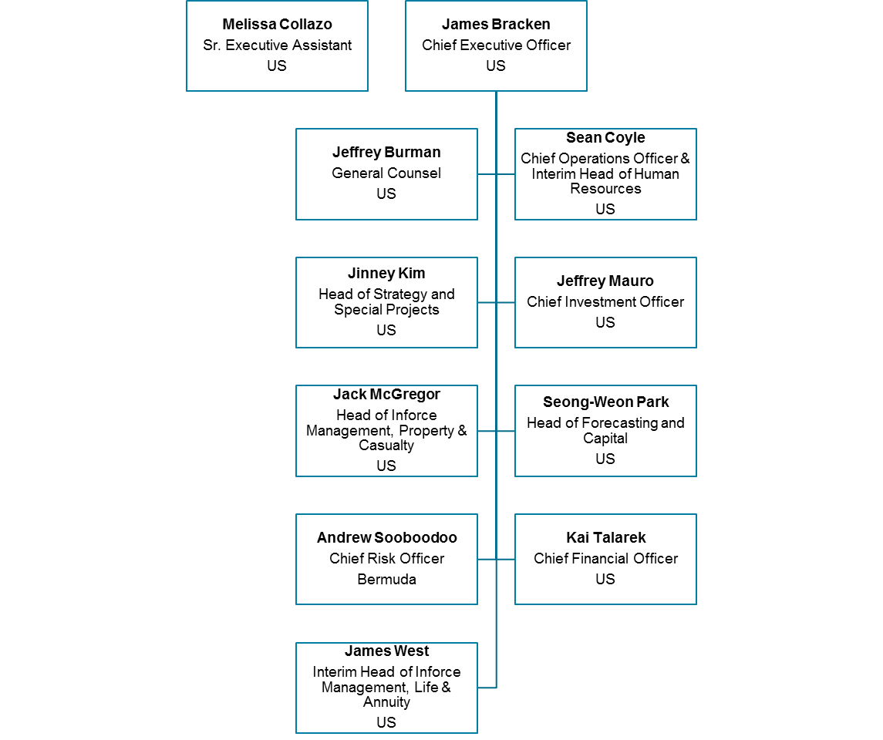

APPENDIX E

RISK MANAGEMENT FRAMEWORK - GOVERNANCE

The Company’s Board is responsible for providing suitable prudential oversight of the insurer’s risk management and internal controls framework, including any activities and functions which are delegated or outsourced.

The Company’s risk management framework is organized around five key aspects:

* Risk Culture and Organization - Forward looking risk function aligned to the Company’s businesses and major risks.
* Risk Governance - Transparency in governance of risk with clear accountability and authority for risk management through policies and committees, as well as robust dialogue across the Company and the Group.
* Risk Identification and Measurement - Risk identification and reporting to drive improved decision making through better information and analytics, including stress testing.
* Risk Appetite and Limits -Clearly defined risk appetite, policies and limits at corporate and business unit level, implemented with robust analytical processes and tools.
* Regulation and Supervision - Enhanced processes, infrastructure and frameworks across the Risk function to comply with regulation and supervision.

The Company utilizes a “Three Lines of Defense” model for risk management:

1. First Line of Defense: Composed of those profit centers and corporate functions that originate risks and have primary responsibility for managing risks, including identifying, assessing, controlling, monitoring, and reporting risk measures;
2. Second Line of Defense: Composed of ERM and other assurance functions, such as Compliance, which perform independent risk assessments; and
3. Third Line of Defense: The Internal Audit Department (IAD) comprises the independent assurance provided to the Audit and Compliance Committee of the Company. IAD will undertake a program of risk-based audits covering aspects of the First and Second Lines of Defense.

APPENDIX E (continued)

RISK MANAGEMENT FRAMEWORK – STRESS TESTING

The BMA requires commercial insurers to conduct prescribed stress/scenario testing and analysis. The objective is to assess the capital adequacy of the insurers under adverse financial market and underwriting conditions and provides a comprehensive understanding of the sector’s general vulnerability to shocks.

In addition, as part of the BMA’s regulatory regime, the Company will be required to submit an assessment of its own risk and solvency requirements to the BMA on an annual basis.

Dividend and/or strategic transaction recommendations would be made to the Board should the testing show that, after payment of the dividend or strategic transaction, the Company would remain above its defined Stress Threshold of 125% BSCR under the stressed scenario.

APPENDIX E (continued)

RISK MANAGEMENT FRAMEWORK – STRESS TESTING

Fortitude Re Stress Testing Framework:

Objectives:

* Estimate potential capital injections under severe economic and insurance scenarios consistent with Fortitude Re’s Risk Appetite Statement
* Estimate BMA Solvency based on stressed MV of assets and technical provisions
* Evaluate upper limits for risky asset investments for assets backing liabilities (high yield and alternative investments) and surplus assets

Scenario Description: The following set of stress tests are used to evaluate Fortitude Re’s capital position based on its most significant risk exposures including property and casualty reserve risk and market/ALM risk.

|  |  |  |
| --- | --- | --- |
|  | **Fortitude Re’s Comprehensive Scenario (“Comp”)** | **Fortitude Re’s Severe Financial Plus (“SFP”)** |
| **Scenario Objectives** | * Achieve comprehensive coverage of Fortitude Re’s risk exposures and assess robustness of Fortitude Re’s balance sheet when all major risk factors are stressed at the same time * Achieve approximately an overall 95th percentile stress impact to Fortitude Re | * Alternative to Comprehensive scenario with losses dominated by financial stress * Achieve approximately an overall 98th percentile stress impact to Fortitude Re |
| **Risk factors to be applied to Fortitude Re** | * 1 in 20 Macroeconomic / Financial Market Stress * 1 in 20 P&C insurance Non-economic Reserve risk | * 1 in 50 Financial Market stress |

Stress Testing Results: The table below reflects the capital position of Fortitude Re based on instantaneous shocks; and shows that the BSCR ratio remains above the stress threshold level of 125% for all scenarios.

* In this analysis we assume that the base line expected dividend of ~$0.5B is distributed in 2020.
* Fortitude Re’s current capital level is self-sufficient even under stressed conditions and does not rely on AIG support to keep the business operational
* The stress impact under the Comp scenario is more severe than the SFP scenario because:
  + The Property & Casualty reserve shocks not only decrease available capital, but also increase the capital requirements for reserve risks
  + The SFP scenario produces higher equity mark-to-market losses, which are mitigated by a greater reduction in the capital requirement

|  |  |  |  |  |  |  |  |  |  |  |  |
| --- | --- | --- | --- | --- | --- | --- | --- | --- | --- | --- | --- |
|  |  |  |  |  |  | ECR Ratio (as of 4Q 2019, Pro-forma) | | | |  |  |
| Description of Stress ($ M) | TAC | BSCR | ECR Ratio | Impact of TAC | Impact on BSCR | Before Stress | Stressed (before capital actions) | After BU capital actions | After Parent Injection | Dividend Changes ($ M) | Parent Capital Injections ($ M) |
| Starting Position (as of Q4 2019) | 4,305 | 1,849 | 233% | 0 | 0 | 233% | 233% | 233% | 233% | 0 | 0 |
| Severe General Insurance Stress (1-20) | 4,058 | 1,930 | 210% | -255 | 59 | 230% | 210% | 210% | 210% | 0 | 0 |
| Moderate Market Stress (1-20) | 3,607 | 1,678 | 215% | -706 | -193 | 230% | 215% | 215% | 215% | 0 | 0 |
| Severe Market Stress (1-50)  (FRL SFP) | 3,422 | 1,647 | 208% | -890 | -224 | 230% | 208% | 208% | 208% | 0 | 0 |
| Severe General Insurance Stress and Moderate Market Stress  (FRL COMP) | 3,524 | 1,735 | 203% | -788 | -136 | 230% | 203% | 203% | 203% | 0 | 0 |

Stress Testing Assumptions (after diversification):

|  | Stress Factors | | | |  | Credit Spread shocks (bps) | | | | | | |
| --- | --- | --- | --- | --- | --- | --- | --- | --- | --- | --- | --- | --- |
| Description of Stress | IR Shock | Equity/Alts Shock | ML III Shock | PC Reserve |  | AAA | AA | A | BBB | BB | B | CCC or lower |
| Severe P&C Stress (1-20) | 0 | 0.0% | 0.0% | 7.2% |  | 0 | 0 | 0 | 0 | 0 | 0 | 0 |
| Moderate Market Stress (1-20) | -24 | -14% | -14% | 0.0% |  | 81 | 131 | 149 | 166 | 267 | 456 | 813 |
| Severe Market Stress (1-50) | -30 | -22% | -23% | 0% |  | 124 | 107 | 137 | 214 | 290 | 443 | 1,096 |

APPENDIX G

**Company Board Committees:**

1. **Audit Committee**

Membership:

Richard Patching (Chair)

Douglas Dachille

Tom Diemer

Spencer Gluck

Kevin Hogan

Brian Schreiber

1. **Risk and Capital Committee (includes Investments)**

Membership:

Geoff Cornell (Co-Chairperson)

Spencer Gluck (Co-Chairperson)

Douglas Dachille

Thomas Diemer

Kevin Hogan

Brian O’Hara

Brian Schreiber

Sabyasachi Ray

Anthony Vidovich

1. **Life & Annuity Reinsurance and Claims Committee**

Membership:

Thomas Diemer (Chairperson)

Douglas Dachille

Kevin Hogan

Richard Patching

Sabyasachi Ray

Brian Schreiber

1. **Property & Casualty Reinsurance and Claims Committee**

Membership:

Brian O’Hara (Chairperson)

Geoffrey Cornell

Spencer Gluck

Anthony Vidovich

Samuel Weinhoff

1. **Compliance Committee**

Membership:

Sabyasachi Ray (Chairperson)

Geoffrey Cornell

Thomas Diemer

Spencer Gluck

Richard Patching

Anthony Vidovich

APPENDIX H

|  |  |
| --- | --- |
| **Department Contacts** | **Actuarial Contacts** |
|  | Ms. Amanda Fenwick  Assistant Chief Life Actuary  New York State Department of Financial Services  One Commerce Plaza  Life Bureau  Albany, New York 12257 |
| Mr. Stephen Doody  Deputy Superintendent  New York State Department of Financial Services  One State Street  Property Bureau 4th Floor  New York, NY 10004 | Ms. Gloria Huberman  Deputy Chief Actuary  New York State Department of Financial Services  One State Street  Property Bureau - 6th Floor  New York, NY 10004 |
| Mr. Mike Arendall  Assistant Chief Analyst  Texas Department of Insurance  333 Guadalupe Street  Austin, Texas 78714-9104 | Mr. Aaron Hodges  Life & Health Actuary  Texas Department of Insurance  333 Guadalupe Street  Austin, Texas 78714-9104 |
| Mr. Joseph DiMemmo  Deputy Commissioner  Pennsylvania Department of Insurance  Office of Corporate and Financial Regulation  1345 Strawberry Square  Harrisburg, PA 17120 | Ms. Melissa Greiner  Director  Pennsylvania Department of Insurance  Office of Corporate and Financial Regulation  1345 Strawberry Square  Harrisburg, PA 17120 |
| Mr. David Lonchar  Chief Financial Examiner  Delaware Insurance Department  841 Silver Lake Blvd.  Dover, DE 19904 |  |
| Mr. Jeff Jackson  Supervisor of Financial Analysis  Illinois Division of Insurance  320 West Washington St.  Springfield, Illinois 62767-0001 |  |
| Mr. John Rehagen  Director  Missouri Department of Insurance  Truman State Office Building  301 West High Street, Room 530  Jefferson City, MO 65102 |  |

APPENDIX I

|  |  |  |  |
| --- | --- | --- | --- |
| **Third Party Administrator** | **Business**  **Administered** | **Ceding Company** | **Policy Count (1)** |
| Alliance-One Services (Subsidiary of DXC Technology) | Whole Life, Excess Interest Whole Life, A&H (Disability, Medical), Single Premium Immediate Annuities, Supplemental Contracts | American General Life, US Life in the City of New York | 310,727 |
|  |
|  |
| Concentrix | Universal Life, Whole Life, Term | American General Life, US Life in the City of New York | 49,461 |
| Long Term Care Group | Long Term Care | American General Life, US Life in the City of New York | 4,804 |
| Bay Bridge Administrators | Cancer Indemnity, Specified Disease Indemnity, Accident Medical Indemnity | National Union Fire Insurance Co | 4,025 |
| Selman & Company | Critical Illness Indemnity, Cancer Indemnity, Accident Indemnity | National Union Fire Insurance Co | 396 |
| Liberty Bankers Life | Supplemental Contracts | American General Life | 2 |
| MetLife  Mercer  Aon-Hewitt and One Main Financial | Supplemental Contracts | American General Life  American General Life  American General Life | 1,420  3,255  89 |
| Single Premium Immediate Annuities |
| Single Premium Immediate Annuities |
| Phoenix Group | Pension Risk Transfer Annuities | American International Reinsurance Company | 14,414 |
| **Total** |  |  | **388,593** |

Outsourced General Business Claims Administration (Workers’ Compensation)

|  |  |
| --- | --- |
| **Third Party Administrator** | **Count of Open Claims (2)** |
| Gallagher Basset Services, Inc. | 309 |
| Broadspire/Crawford | 207 |
| Constitution State Services | 137 |
| Claims Management, Inc. | 87 |
| Sedgwick Claims MGT Services | 71 |
| Tristar Insurance Group | 54 |
| Liberty Helmsman (Buyouts) | 46 |
| ESIS (incl. Stroehmann Buyout) | 39 |
| Other | 93 |
|  |  |
|  |  |
|  |  |
|  |  |
|  |  |
|  |  |
|  |  |

(1) As of June 30, 2019. (2) As of March 31, 2017 (3) Alliance-One began administration of AGL/USL’s policies on July 17, 2017. The program to outsource administration to Alliance One commenced in 2015 and was methodically tested during 2016/2017 before the go-live date.

1. With authorized share capital of US$1.25 million of US$1.00 par value each and a contribution to surplus comprising the following key elements: US$2.7 billion of Statutory Capital in cash and securities and alternative investments; US$550 million in the form of an irrevocable standby letter of credit in favor of the Company provided by AIG, as approved by the Authority (“Parent LOC”); and Statutory Economic Surplus of $600 million (from the excess of the market value of the ModCo/Funds withheld assets, over Technical Provisions, and Deferred Tax Assets), which included the approved Tier 1 capital credit of US$330M.
2. The following abbreviations are used AGL: American General Life Insurance Company, AIGB:AIG Life of Bermuda, ALBA: NUFIC: National Union Fire Insurance Company, USL: United States Life Insurance Company, VALIC: Variable Annuity Life Insurance Company
3. Includes a small amount of SunAmerica Traditional business
4. Primarily composed of legacy Universal Life policies acquired under rehabilitation of the Mutual Benefit Life Insurance Company, which focused on serving upper classes
5. TFAs include, in addition to the US Life & Retirement Portfolios, a TFA on Scottish lives currently reinsured to AIRCO and retroceded to Fortitude Re (see Appendix H)